**VISUALITATION TOOL FOR ELECTRIC VEHICLE CHARGE AND RANGE ANALYSIS**

1. **Introduction**

* Overview

A vehicle that can be powered by an electric motor that draws electricity from a battery and is capable of being charged from an external source and have an electric motor instead of an internal combustion engine.

* Purpose

Electric vehicles use electricity to charge their batteries instead of using fossil fuels like petrol or diesel. Electric vehicles are more efficient, and that combined with the electricity cost means that charging an electric vehicle is cheaper than filling petrol or diesel for your travel requirement.

**2.Problem Definition & Design Thinking**

* Empathy map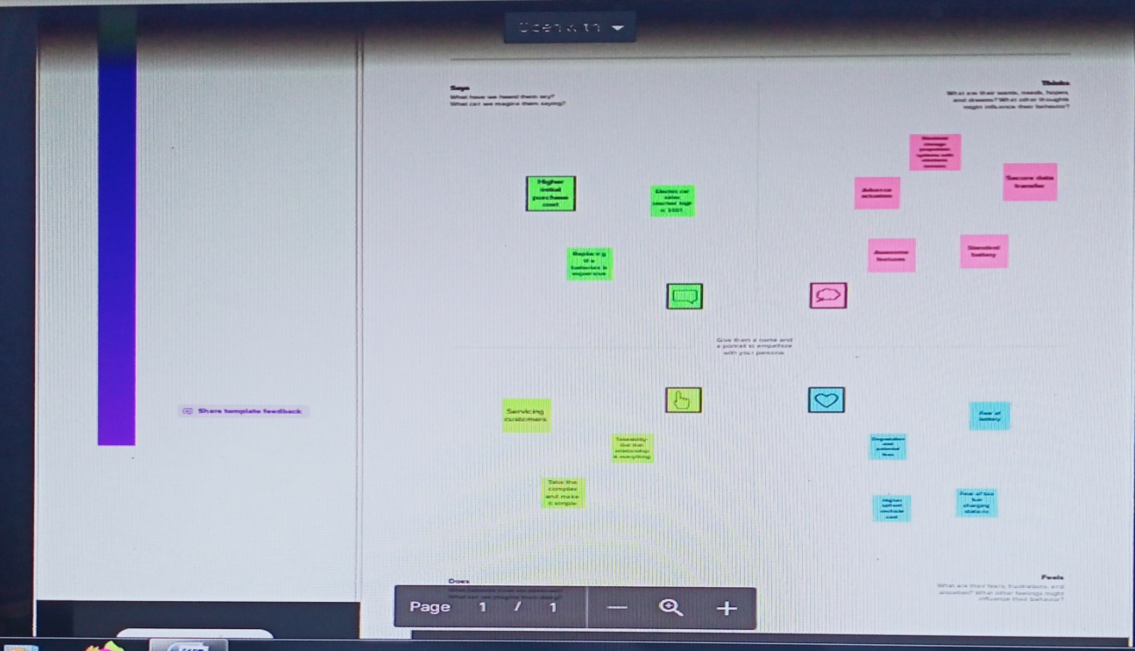

* Brainstorming map

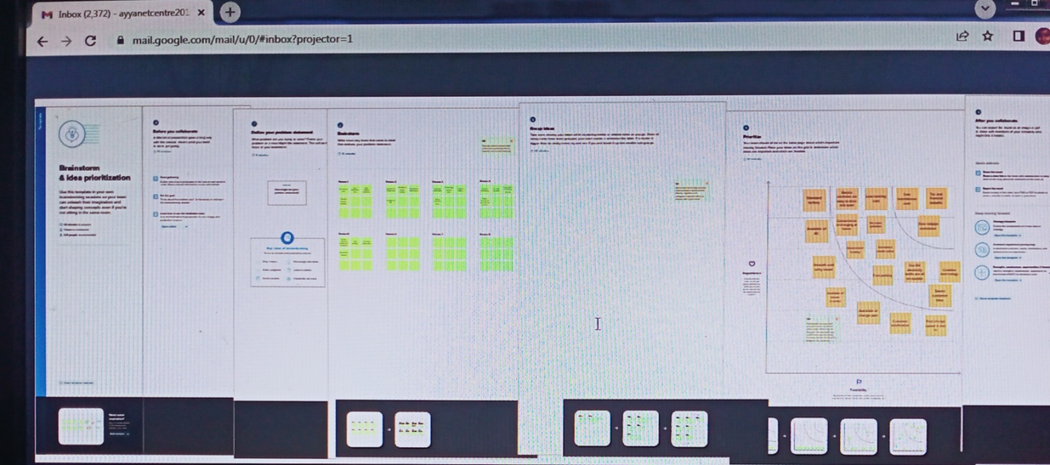

**3.Result**

We have used the dataset to create visualization. Then we have organized the data into dashboard and story which is data in an organized easy-to-read format.

* Dashboard

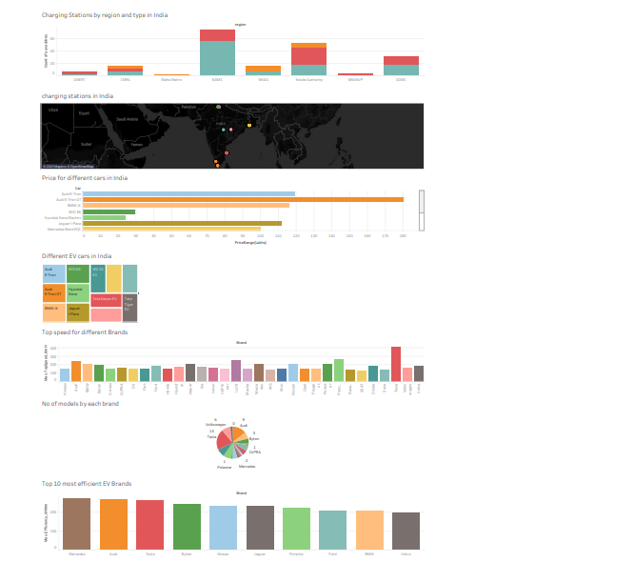



* Story

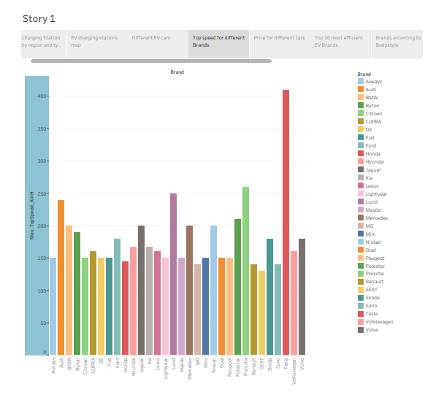

**4.Advantages and Disadvantages**

* Advantage
  + - * No fuel required so you save money on gas
* Environmental friendly as they do not emit pollutants
* Lower maintenance due to an efficient electric motor
* Better Performance
* Less maintenance
* Disadvantage
* Limited Battery Range. The average petrol car can easily do four or five hundred miles on a tank of petrol
* Battery Lifespan Concerns
* Charging Infrastructure Worries
* Long Charging Times
* Low Top Speeds

**5.Applications**

* Transformers & Power Engineering
* Electro-Structural
* Magnetic Gears
* Motors and Generators
* EV Battery Charging.

**6.Conclusion**

The progress that the electric vehicle industry has seen in recent years is not only extremely welcomed, but highly necessary in light of the increasing global greenhouse gas levels. As demonstrated within the economic, social, and environmental analysis sections of this webpage, the benefits of electric vehicles far surpass the costs. The biggest obstacle to the widespread adoption of electric-powered transportation is cost related, as gasoline and the vehicles that run on it are readily available, convenient, and less costly. As is demonstrated in our timeline, we hope that over the course of the next decade technological advancements and policy changes will help ease the transition from traditional fuel-powered vehicles. Additionally, the realization and success of this industry relies heavily on the global population, and it is our hope that through mass marketing and environmental education programs people will feel incentivized and empowered to drive an electric-powered vehicle. Each person can make a difference, so go electric and help make a difference!

**7.Future Scope**

* [There are no emissions](https://kineticgreenvehicles.com/blog/why-electric-vehicles-are-the-future/#point21)
* [Access to city centres is unrestricted](https://kineticgreenvehicles.com/blog/why-electric-vehicles-are-the-future/#point22)
* [Electricity is less expensive than gasoline](https://kineticgreenvehicles.com/blog/why-electric-vehicles-are-the-future/#point23)
* [Comfortable and quiet](https://kineticgreenvehicles.com/blog/why-electric-vehicles-are-the-future/#point24)
* [There's no need to switch gears](https://kineticgreenvehicles.com/blog/why-electric-vehicles-are-the-future/#point25)
* [Torque on the fly](https://kineticgreenvehicles.com/blog/why-electric-vehicles-are-the-future/#point26)
* [Extremely effective](https://kineticgreenvehicles.com/blog/why-electric-vehicles-are-the-future/#point27)
* [Requires less maintenance](https://kineticgreenvehicles.com/blog/why-electric-vehicles-are-the-future/#point28)
* [Generate your power](https://kineticgreenvehicles.com/blog/why-electric-vehicles-are-the-future/#point29)